AMD Hands on Lab: AWS Optimization with AMD-Powered Instances

Abstract
There are a variety of CPU choices available to AWS customers, and selecting the “best” CPU is not a simple proposition. There are over 850 instance types available on AWS, built using three CPU vendors: AMD, Graviton, and Intel. At the time of writing, AMD offers the best overall performance and efficiency on AWS, regardless of x86 or ARM architecture. I know you are reading this and thinking, of course AMD is going to say that. As you work through this workshop, you will get hands-on with AMD-specific scenarios on AWS and data to back up our bold claims.

Since 2006, AWS has offered (in beta) on-demand compute with Amazon Elastic Compute Cloud (EC2). Then, in October 2008, EC2 launched publicly. At the time of launch, AWS only offered a single CPU choice: Intel. Picking the best instance was simply picking the best AWS “t-shirt” size for your workload. In 2018, AWS offered AMD and Graviton instances, and selecting an instance became a lot more complicated. Now you must decide between ARM (Graviton) and x86 (AMD and Intel). Performance and efficiency can swing significantly between AMD, Graviton, and Intel processors.

In this workshop, you will get hands-on experience with:
- Using simple prime number calculations to estimate CPU performance
- Converting an EC2 instance from Intel to AMD
- Optimizing an instance’s vCPU count to save money on licensing
- EC2 instance network tuning options
- How to access your CUR
Upcoming content:
- Updating ECS/EKS workloads to use AMD instead of Intel

Activity 0 – Deploying the pre-reqs
- In the Amazon CloudFormation console, select Create stack \ With new resources (standard)

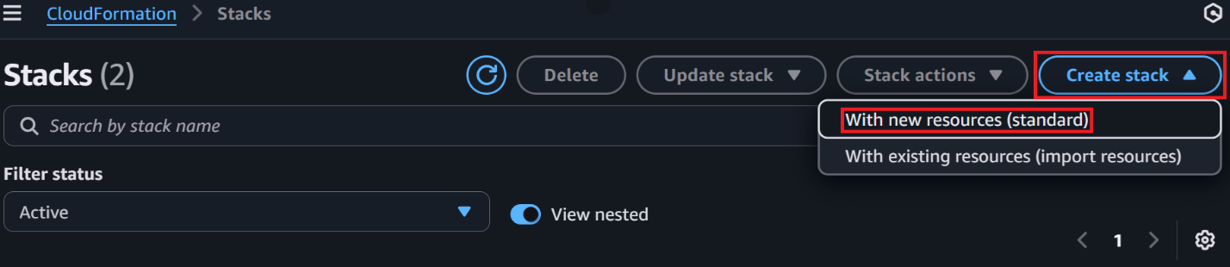
- On the Create stack page, set the following and select Next
  - Prepare template: Choose an existing template
  - Template source: Upload a template file
  - Choose file: Select the AMD-HOL-AWS.yml file you downloaded

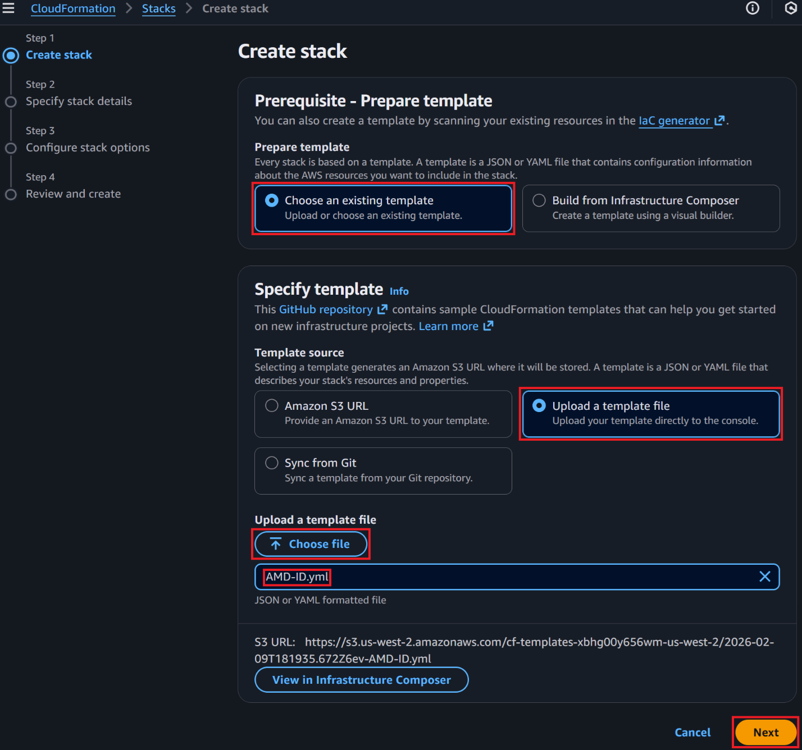

- On the Specify stack details page, set the following and select Next
  - Stack name: AMD-HOL-<your initials>

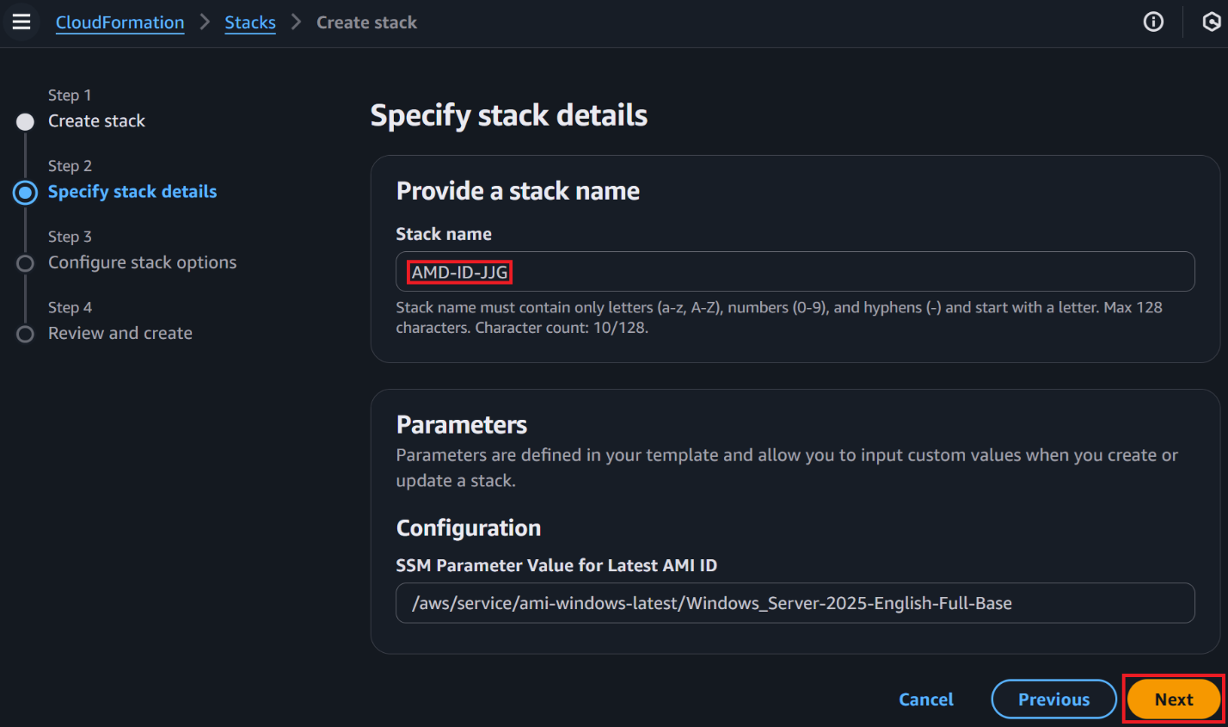

- On the Configure stack options page, set the following and select Next
  - I acknowledge that AWS CloudFormation might create IAM resources with custom names: Checked
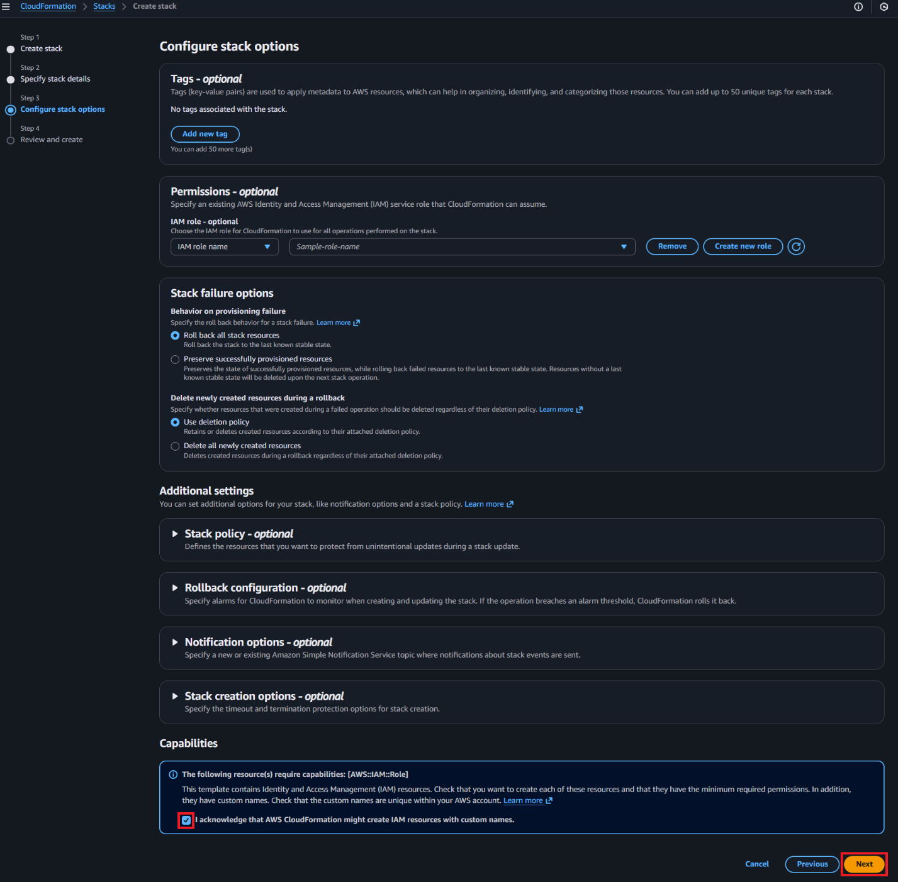
- On the Review and create page, review your settings and select Submit
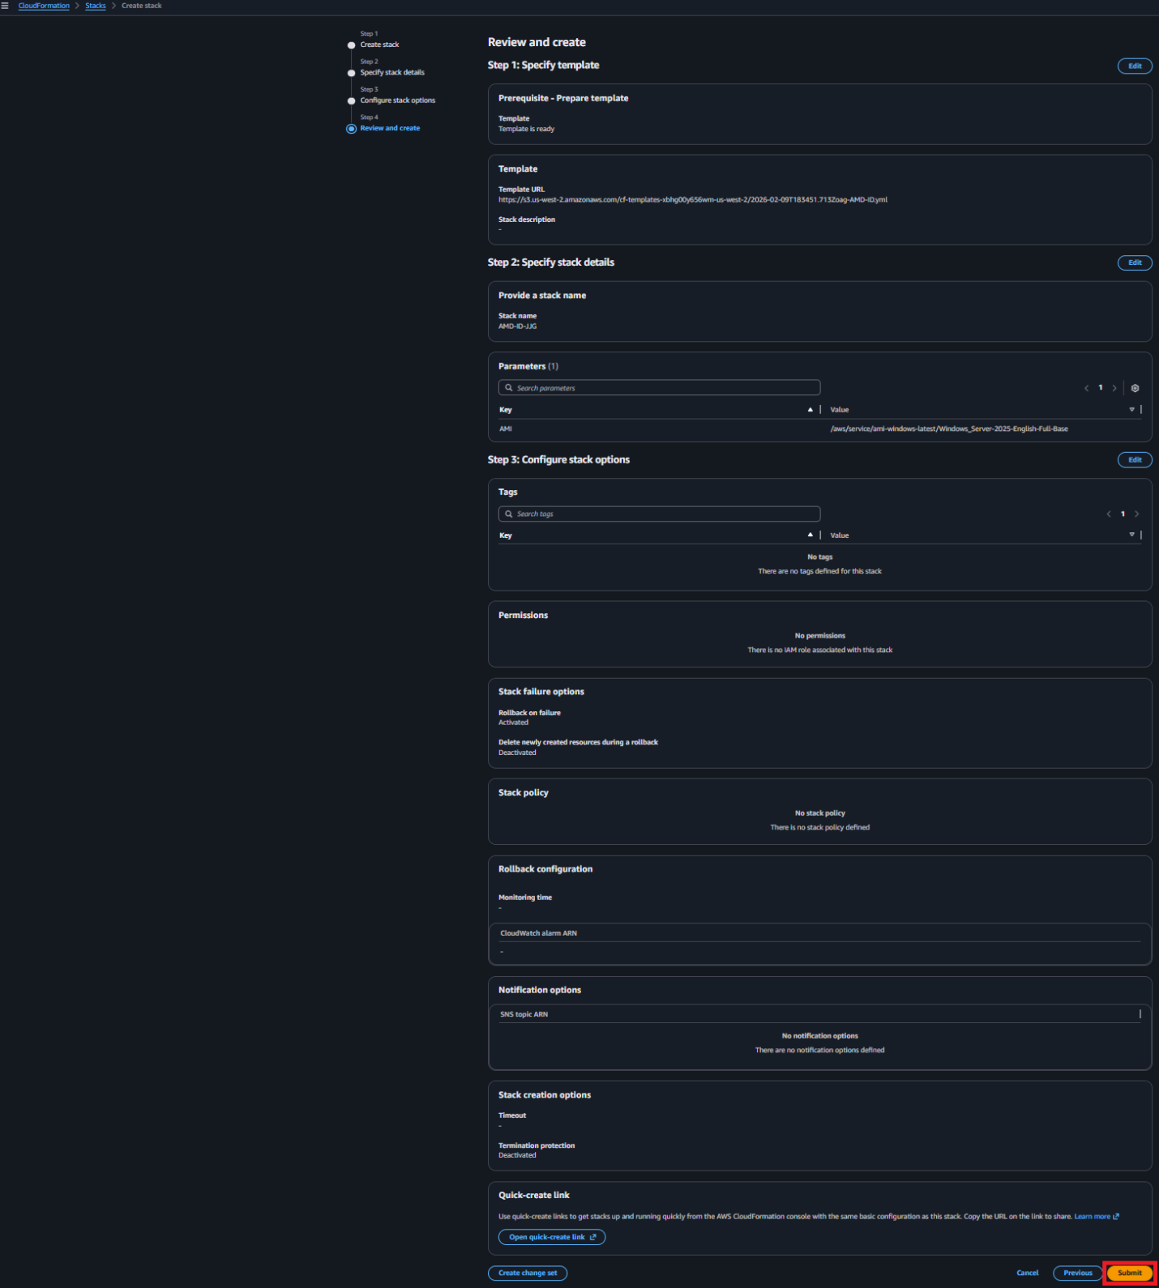
Note: It will take about 10 minutes for the template to fully deploy.

Activity 1 – Testing CPU performance with prime math
In this activity, you will invoke a prime number math performance test to gauge the CPU performance of the existing instance type with a recommended replacement. This is not a benchmark, as you are not assessing a workload. Based on experience, the results line up with most benchmarks as it tests raw CPU performance. This activity will expose you to a few of AWS’s management tools. These are great tools for managing and monitoring your AWS fleet. For more information on the prime number test, click here.

- In the AWS Systems Manager Documents console, select the Owned by me tab
- In the Documents search window, enter -id and press Enter to find the SSM documents for this activity
- In the AWS Systems Manager Documents page, select the document named PrimeNumberTest-XX (xx = the CF stack name), by selecting its name

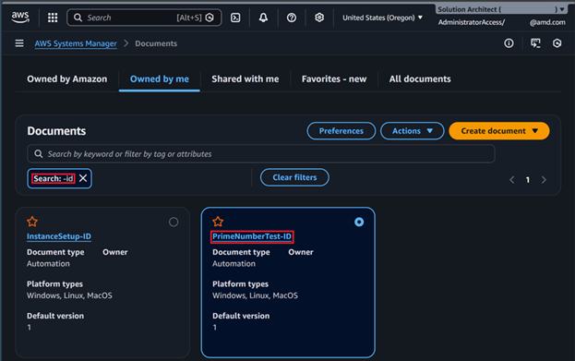
- In the AWS Systems Manager PrimeNumberTest-XX document page, select Execute automation
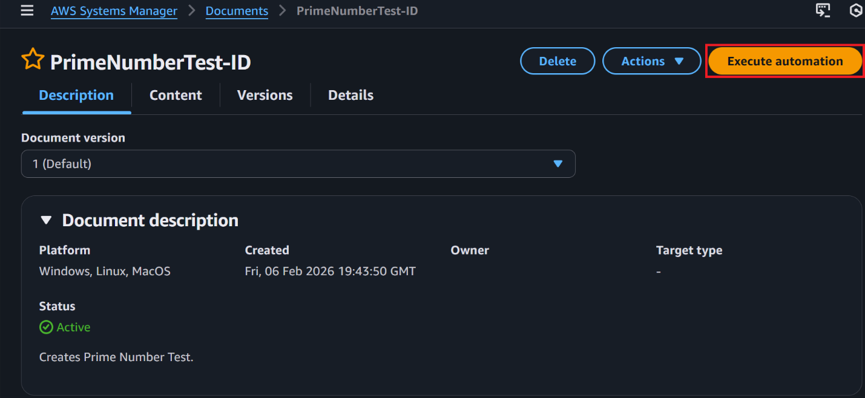
- In the AWS Systems Manager Execute automation runbook page, set the following and select Execute:
  - Execution type: Simple execution
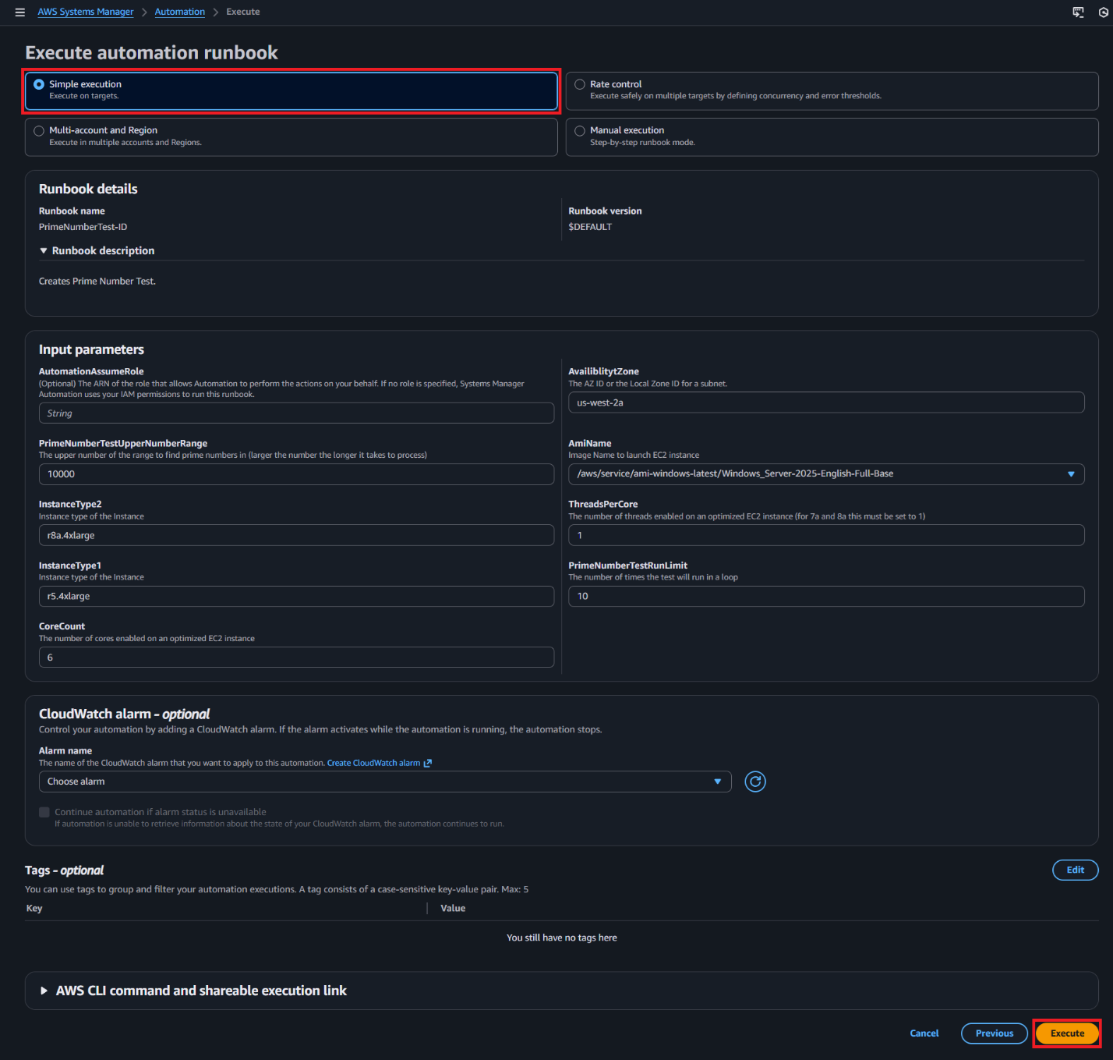

The test will take around 15 minutes to run. Start working on Activity 2. You will come back to review the results in a later activity.

Activity 1-1 – Testing CPU performance with prime math, the AWS PowerShell way
Below are the PowerShell commands to launch the prime number math test.
$Params = @{
AmiName = '/aws/service/ami-windows-latest/Windows_Server-2025-English-Full-Base'
AvailiblityZone = 'us-west-2a'
InstanceType1 = 'r5.4xlarge'
InstanceType2 = 'r8a.4xlarge'
CoreCount = 6
ThreadsPerCore = 1
PrimeNumberTestRunLimit = '10'
PrimeNumberTestUpperNumberRange = '10000'
}

# Replace XX with actual characters from the AWS console
Start-SSMAutomationExecution -DocumentName 'PrimeNumberTest-XX' -Parameter $Params

Activity 2 – Converting an instance from Intel to AMD
In this activity, you will convert an Intel-powered r5.4xlarge instance, like tested above, to the AMD-powered r8a.4xlarge. In this activity, you have two paths to completion: the console or AWS PowerShell (API). The recommended approach to converting instances in production is to use scripts of IaC using AWS APIs. This prevents accidental human errors and programmatically sets everything as it should be. Note, these steps are the same if you are running a r6a.4xlarge and want to upgrade to the latest r8a.4xlarge instance.

Activity 2-1 Stop your instance
- In the EC2 Console, select Instances in the left-hand navigation pane
- Right-click on the EC2 instance named AMD-ID-01 and select Stop instance
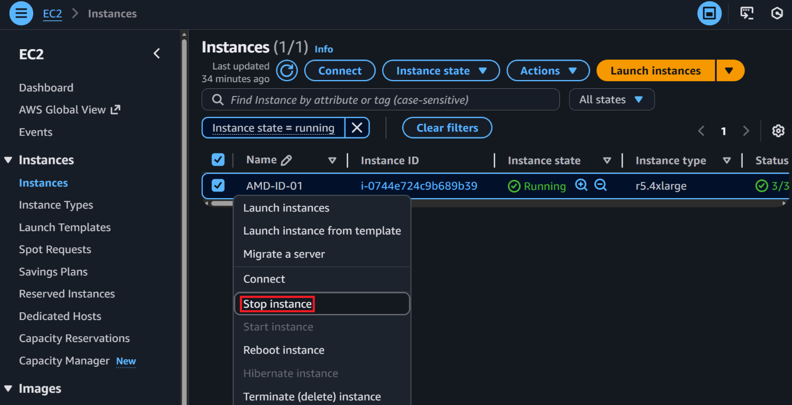
- The Stop instance dialog will appear. Leave Skip OS shutdown, unchecked and select Stop
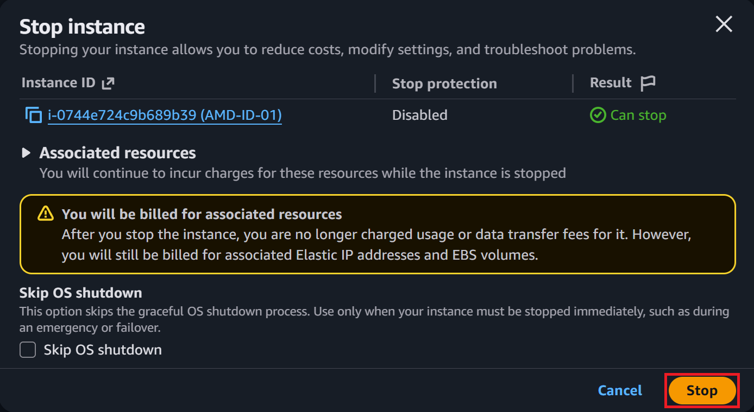

The instance will be in a stopped state in 2 minutes or fewer.

Activity 2-2 Change your instance type
- Once the instance is in a stopped state, right-click on the EC2 instance named AMD-ID-01 and select Instance settings > Change instance type
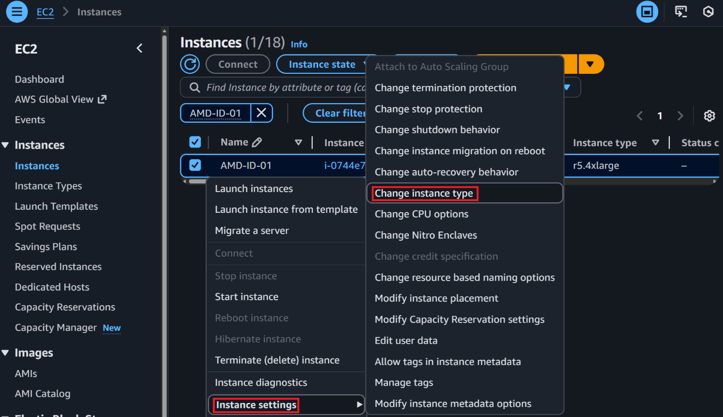
- In the Change instance type page, enter r8a.4xlarge and select r8a.4xlarge
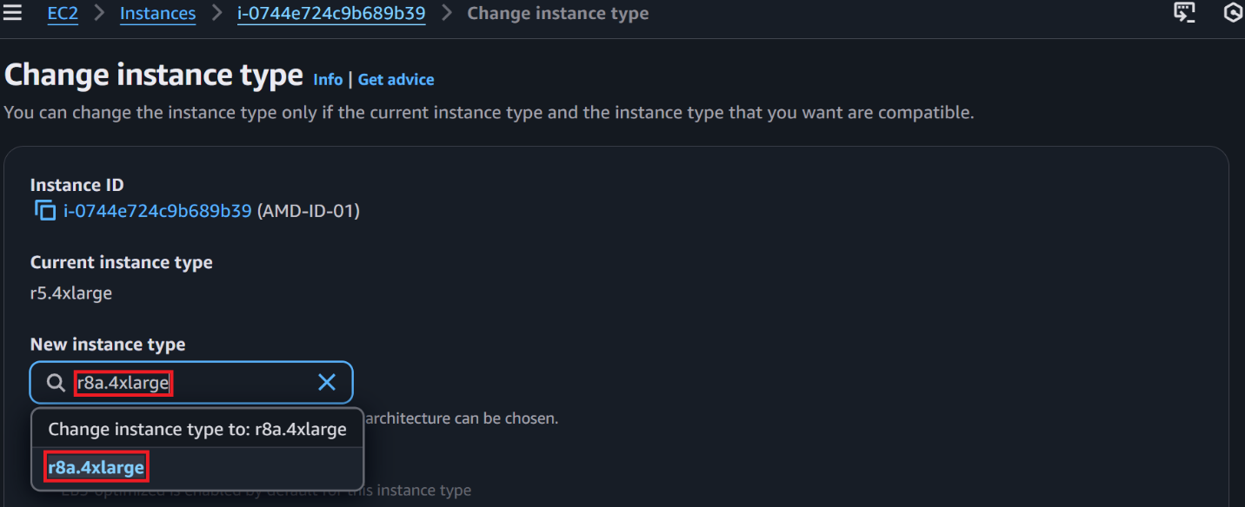
- Scroll to the bottom of the page and select Change instance type
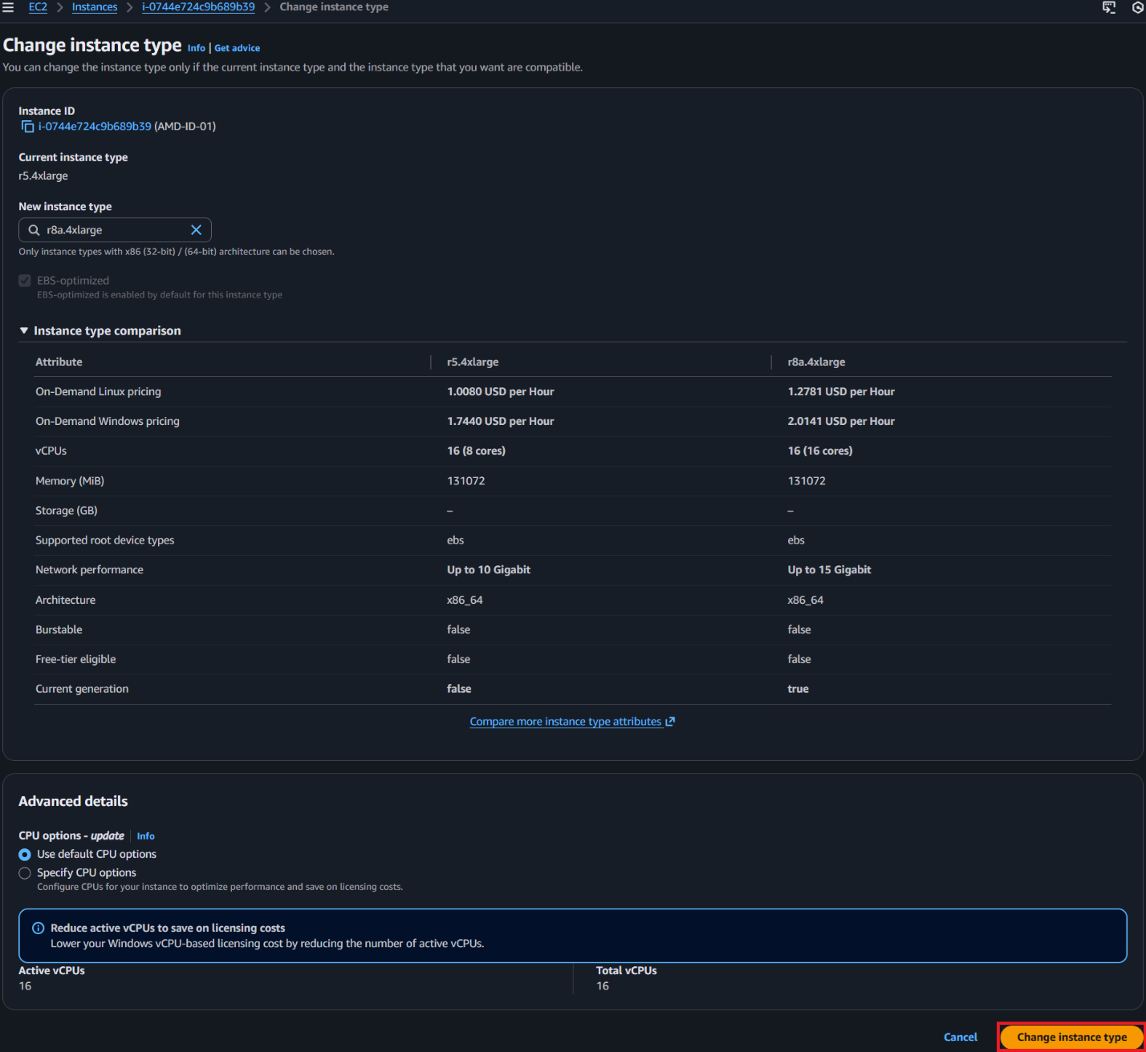

The keen eye may have noticed the CPU options-update setting on the Change instance type page. It is possible to optimize and convert at the same time. It is the recommended approach for migrating to AMD-powered instances. For the sake of learning, we are splitting the activities.

Activity 2-3 Start your instance
- Right-click on the EC2 instance named AMD-ID-01 and select Start instance
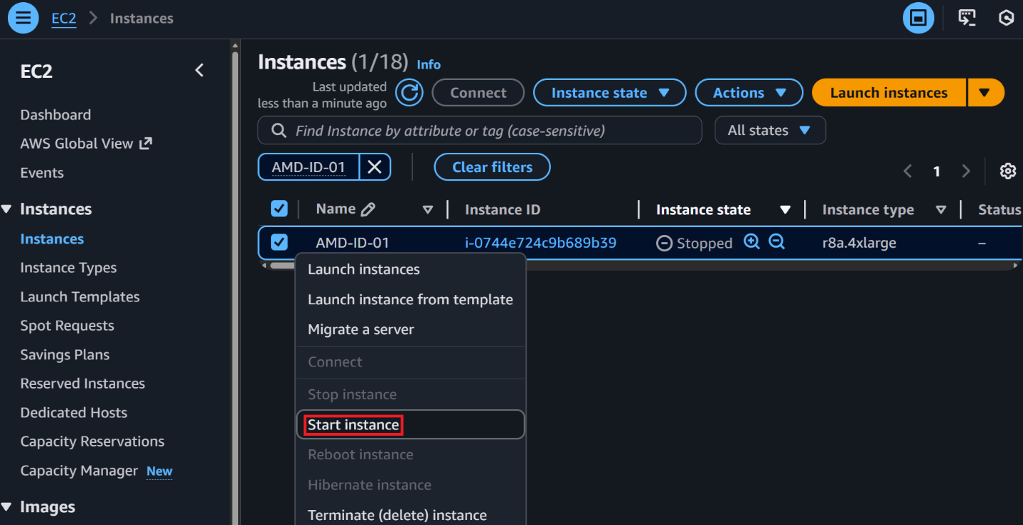
The instance will begin its startup sequence and should complete it in 2 minutes or fewer.

You have now successfully converted, and EC2 instance from Intel to AMD. But you did not optimize the vCPU count to get the maximum value. As it stands today, r8a.4xlarge costs $1.27808/hour and r5.4xlarge costs $1.008/hour. That is over $0.27 per hour more! Why would you do this? The next section will optimize the workload to drive Windows Server licensing savings with the r8a.4xlarge instance to get the price significantly lower than the r5.4xlarge.

Activity 2-3 Converting an instance from Intel to AMD, the AWS PowerShell way
Below are the PowerShell commands to convert AMD-ID-01 from an r5.4xlarge to a r8a.4xlarge.
#### Variables ####
$Region = 'us-west-2'
$DesiredInstanceType= 'r8a.4xlarge'

#### Main ####

Write-Output "Getting EC2 instance information for $InstanceId."
Try {
$InstanceDetails = Get-EC2Instance -Filter @{ Name = 'tag:Name'; Values = 'AMD-ID-01' } -Region $Region -ErrorAction Stop
} Catch [System.Exception] {
Return "Unable to get EC2 instance information. $_"
}

$State = $InstanceDetails | Select-Object -ExpandProperty 'Instances' | Select-Object -ExpandProperty 'State' | Select-Object -ExpandProperty 'Name' | Select-Object -ExpandProperty 'Value'
$InstanceType = $InstanceDetails | Select-Object -ExpandProperty 'Instances' | Select-Object -ExpandProperty 'InstanceType' | Select-Object -ExpandProperty 'Value'

If ($InstanceType | Where-Object { $_ -like "*g.*" }) {
Return "EC2 instance is a Graviton (ARM) Instance, switching between ARM and x86 is not supported and will fail to launch."
}

If ($InstanceType -ne $DesiredInstanceType) {
If ($State -ne 'stopped') {
Write-Output "EC2 instance $InstanceId is currently running, stopping the EC2 instance to change it's type."
Try {
$Null = Stop-EC2Instance -InstanceId $InstanceId -Force -Region $Region -ErrorAction Stop
} Catch [System.Exception] {
Return "Failed to execute stop command on EC2 instance $InstanceId. $_"
}
Start-Sleep -Seconds 5
$StopInstanceCounter = 0
Do {
$State = Get-EC2Instance -InstanceId $InstanceId -Region $Region -ErrorAction SilentlyContinue | Select-Object -ExpandProperty 'Instances' | Select-Object -ExpandProperty 'State' | Select-Object -ExpandProperty 'Name' | Select-Object -ExpandProperty 'Value'
If ($State -ne 'Stopped') {
$StopInstanceCounter ++
Write-Output "EC2 instance $InstanceId is still stopping, sleeping 5 seconds and will check again."
Start-Sleep -Seconds 5
}
} Until ($State -eq 'Stopped' -or $StopInstanceCounter -ge 120)
}

If ($StopInstanceCounter -ge 60) {
Return "Instance $InstanceId failed to stop in a reasonable time."
}

Write-Output "Updating the EC2 instance $InstanceId instance type from $InstanceType to $DesiredInstanceType."
Try {
Edit-EC2InstanceAttribute -InstanceId $InstanceId -Attribute "instanceType" -Value $DesiredInstanceType -Region $Region -ErrorAction Stop
} Catch [System.Exception] {
Return "Failed to update EC2 instance $InstanceId to $DesiredInstanceType instance type. $_"
}

Write-Output "Starting EC2 instance $InstanceId."
Try {
$Null = Start-EC2Instance -InstanceId $InstanceId -Force -Region $Region -ErrorAction Stop
} Catch [System.Exception] {
Return "Failed to start EC2 instance $InstanceId. $_"
}

Start-Sleep -Seconds 5
$StartInstanceCounter = 0
Do {
$State = Get-EC2Instance -InstanceId $InstanceId -Region $Region -ErrorAction SilentlyContinue | Select-Object -ExpandProperty 'Instances' | Select-Object -ExpandProperty 'State' | Select-Object -ExpandProperty 'Name' | Select-Object -ExpandProperty 'Value'
If ($State -ne 'Running') {
$StartInstanceCounter ++
Write-Output "EC2 instance $InstanceId is still starting, sleeping 5 seconds and will check again."
Start-Sleep -Seconds 5
}
} Until ($State -eq 'Running' -or $StartInstanceCounter -ge 120)

If ($StartInstanceCounter -ge 60) {
Return "Instance $InstanceId failed to start in a reasonable time."
}
Write-Output "EC2 instance $InstanceId converted and back online."
} Else {
Write-Output "EC2 instance $InstanceId instance already set to the desired EC2 instance type."
}

Activity 3 – Optimizing vCPU count to save money on licensing
In this activity, you will use AWS’ Optimize CPU feature to reduce your Windows licensing burden on the instance you just converted to AMD. This is where we will get the cost of the r8a.4xlarge ($1.27808/hour -> $0.81808/hour) below the r5.4xlarge ($1.008/hour). While you can also optimize the CPU at the same time as the conversion (using the console), it is more impactful to learn to do them separately. For more information, click here.

Activity 3-1 – Looking at results in CloudWatch
- In the CloudWatch Metrics console search window, enter "Prime-Number-Testing-Metrics"
- Select Prime-Number-Testing-Metrics > InstanceType
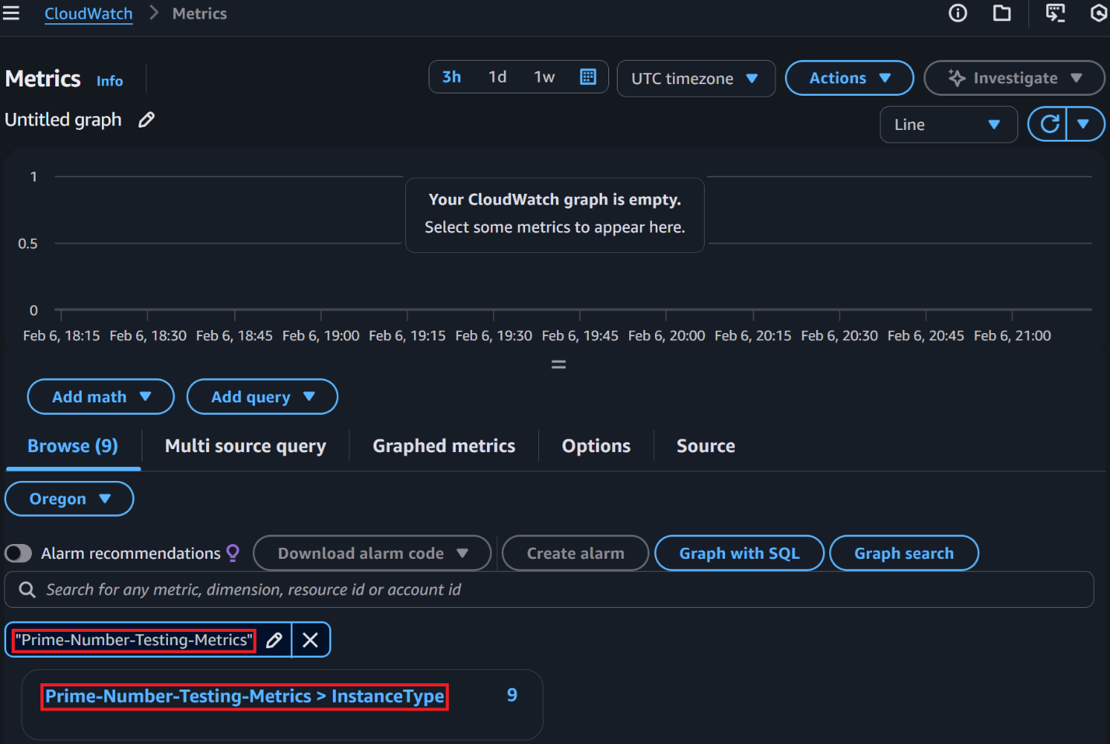
- You should see nine (9) metrics listed; select all metrics
- The default view is a line graph; change the view to Data table
- Min / Max / Sum / Average have the same number; the test publishes a single data point
- Using Max as a reference, it takes 2x longer for the r5.4xlarge to process the same problem as the r8a.4xlarge
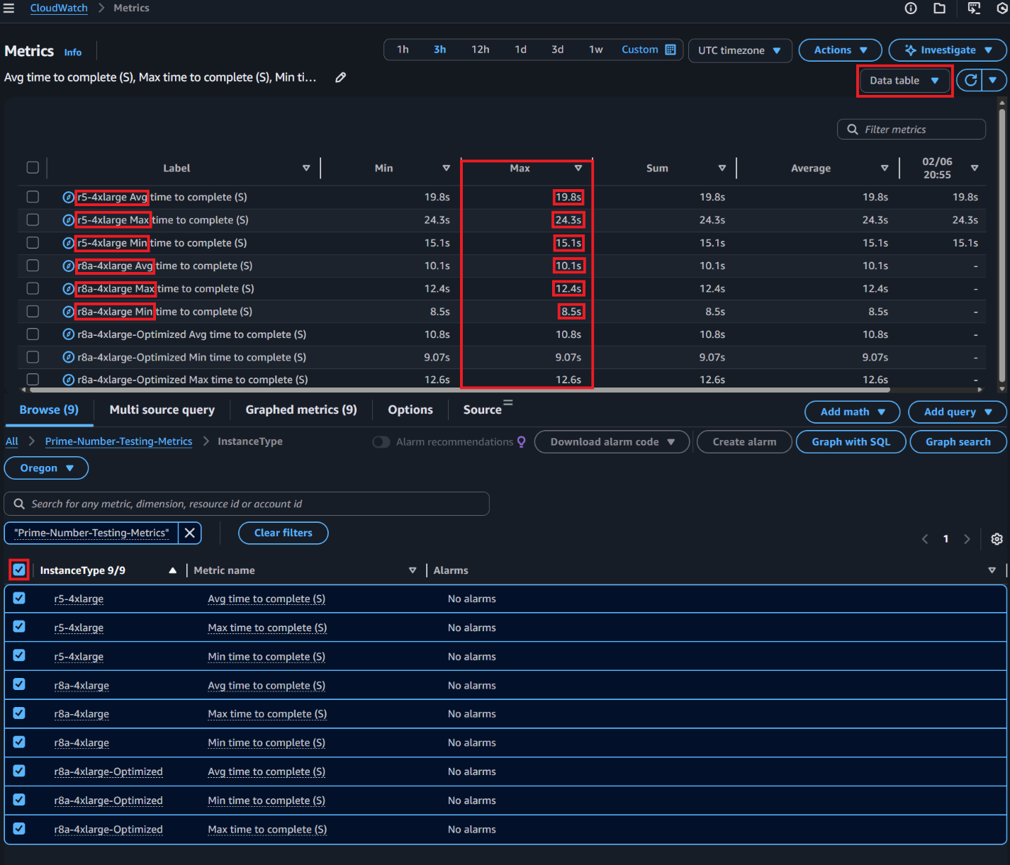
- There is also a r8a-4xlarge-Optimized entry; this instance had its vCPU count reduced to 6, reducing the instance cost by $0.46 per hour! The r8a.4xlarge, despite having 10 fewer vCPUs, outperformed the r5.4xlarge in the test!

What do you see? If in a facilitated environment, share your insights with the attendees when asked.

Activity 3-2 – Optimizing your instance
In this activity, you will reduce the vCPU count to 6 vCPUs of your recently converted r8a-4xlarge instance to save money on Windows licensing without sacrificing performance.

Activity 3-2-1 Stop your instance
- In the EC2 Console, select Instances in the left-hand navigation pane
- Right click on the EC2 instance named AMD-ID-01 and select Stop instance
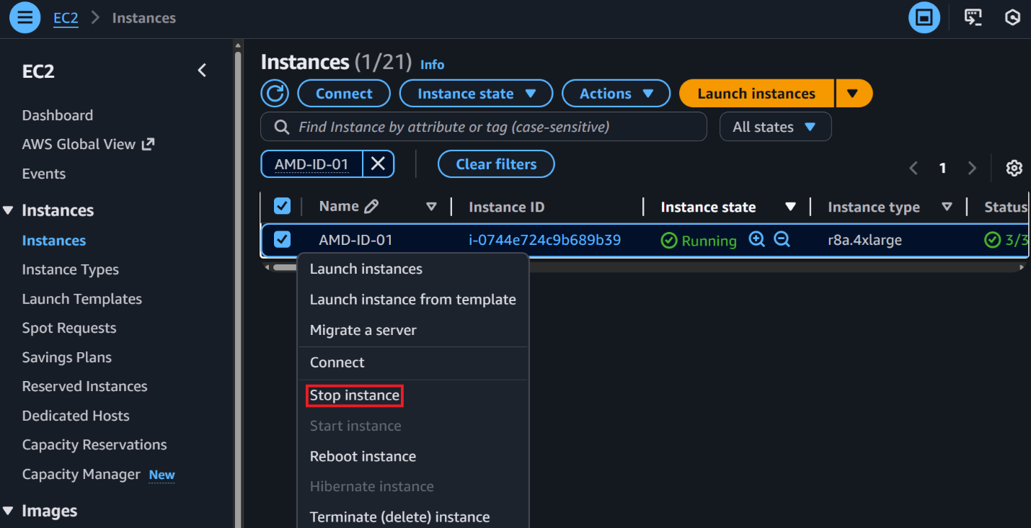
- The Stop instance dialog will appear. Leave Skip OS shutdown, unchecked and select Stop

The instance will shut down in 2 minutes or fewer.

Activity 3-2-2 Change your instance type
- Right-click on the EC2 instance named AMD-ID-01 and select Instance settings > Change CPU options
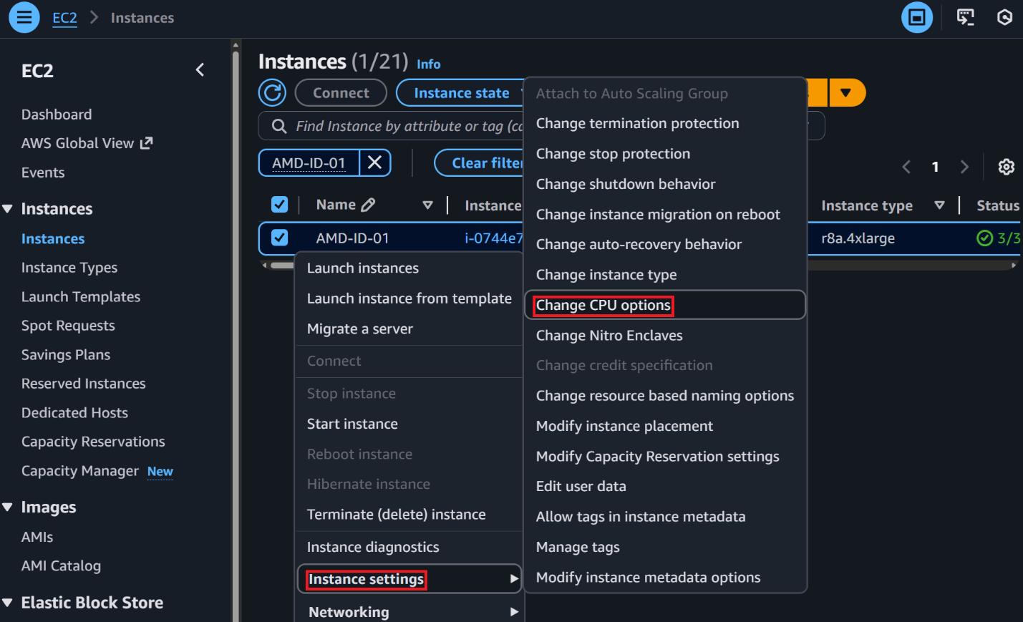
- In the Change CPU options page, set and select Change:
  - CPU options – update: Specify CPU options
  - Active vCPUs, thread(s): 1
  - Active vCPUs, core(s): 6
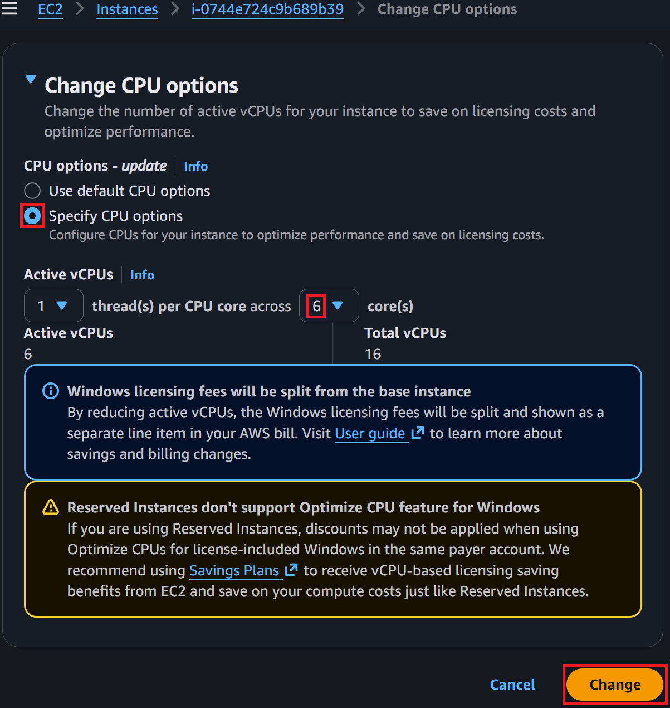

Activity 3-2-3 Start your instance
- Right-click on the EC2 instance named AMD-ID-01 and select Start instance

The instance will begin its startup sequence and should complete it in 2 minutes or fewer.

Congratulations, you have now reduced the cost of running a modern r8a.4xlarge ($1.27808/hour -> $0.81808/hour) by $0.18992 below the r5.4xlarge ($1.008/hour). While this number sounds small, it equals $1663.70 saving on a single server over a year. The savings with a large fleet would be significant.

Activity 3-3 Optimizing vCPU count to save money on licensing, the AWS PowerShell way
Below are the PowerShell commands to set the vCPU count on AMD-ID-01 to 6 vCPUs from 16. Saving $0.46 per hour!

#### Variables ####
$Region = 'us-west-2'
$DesiredvCPUCount = 6

#### Main ####

Write-Output "Getting EC2 instance information for $InstanceId."
Try {
$InstanceDetails = Get-EC2Instance -Filter @{ Name = 'tag:Name'; Values = 'AMD-ID-01' } -Region $Region -ErrorAction Stop
} Catch [System.Exception] {
Return "Unable to get EC2 instance information. $_"
}

$State = $InstanceDetails | Select-Object -ExpandProperty 'Instances' | Select-Object -ExpandProperty 'State' | Select-Object -ExpandProperty 'Name' | Select-Object -ExpandProperty 'Value'
$InstanceType = $InstanceDetails | Select-Object -ExpandProperty 'Instances' | Select-Object -ExpandProperty 'InstanceType' | Select-Object -ExpandProperty 'Value'
$vCPUCount = $InstanceDetails | Select-Object -ExpandProperty 'Instances' | Select-Object -ExpandProperty 'CpuOptions' | Select-Object -ExpandProperty 'CoreCount'
If ($InstanceType | Where-Object { $_ -like "*g.*" }) {
Return "EC2 instance is a Graviton (ARM) Instance, switching between ARM and x86 is not supported and will fail to launch."
}

If ($vCPUCount -ne $DesiredvCPUCount) {
If ($State -ne 'stopped') {
Write-Output "EC2 instance $InstanceId is currently running, stopping the EC2 instance to change it's vCPUs to $DesiredvCPUCount."
Try {
$Null = Stop-EC2Instance -InstanceId $InstanceId -Force -Region $Region -ErrorAction Stop
} Catch [System.Exception] {
Return "Failed to execute stop command on EC2 instance $InstanceId. $_"
}
Start-Sleep -Seconds 5
$StopInstanceCounter = 0
Do {
$State = Get-EC2Instance -InstanceId $InstanceId -Region $Region -ErrorAction SilentlyContinue | Select-Object -ExpandProperty 'Instances' | Select-Object -ExpandProperty 'State' | Select-Object -ExpandProperty 'Name' | Select-Object -ExpandProperty 'Value'
If ($State -ne 'Stopped') {
$StopInstanceCounter ++
Write-Output "EC2 instance $InstanceId is still stopping, sleeping 5 seconds and will check again."
Start-Sleep -Seconds 5
}
} Until ($State -eq 'Stopped' -or $StopInstanceCounter -ge 120)
}

If ($StopInstanceCounter -ge 60) {
Return "Instance $InstanceId failed to stop in a reasonable time."
}

Write-Output "Updating the EC2 instance $InstanceId to $DesiredvCPUCount vCPUs."
Try {
Edit-EC2InstanceCpuOption -InstanceId $InstanceId -CoreCount $DesiredvCPUCount -ThreadsPerCore 1 -Region $Region -ErrorAction Stop
} Catch [System.Exception] {
Return "Failed to update EC2 instance $InstanceId to $DesiredvCPUCount vCPUs. $_"
}

Write-Output "Starting EC2 instance $InstanceId."
Try {
$Null = Start-EC2Instance -InstanceId $InstanceId -Force -Region $Region -ErrorAction Stop
} Catch [System.Exception] {
Return "Failed to start EC2 instance $InstanceId. $_"
}

Start-Sleep -Seconds 5
$StartInstanceCounter = 0
Do {
$State = Get-EC2Instance -InstanceId $InstanceId -Region $Region -ErrorAction SilentlyContinue | Select-Object -ExpandProperty 'Instances' | Select-Object -ExpandProperty 'State' | Select-Object -ExpandProperty 'Name' | Select-Object -ExpandProperty 'Value'
If ($State -ne 'Running') {
$StartInstanceCounter ++
Write-Output "EC2 instance $InstanceId is still starting, sleeping 5 seconds and will check again."
Start-Sleep -Seconds 5
}
} Until ($State -eq 'Running' -or $StartInstanceCounter -ge 120)

If ($StartInstanceCounter -ge 60) {
Return "Instance $InstanceId failed to start in a reasonable time."
}
Write-Output "EC2 instance $InstanceId set to $DesiredvCPUCount vCPUs and back online."
} Else {
Write-Output "EC2 instance $InstanceId instance already set to $DesiredvCPUCount vCPUs."
}

Activity 4 – IO Performance tuning of your AMD instances

Another performance item to consider is disk and network IO. These are the next areas after the CPU and memory where you will find resource starvation. Another benefit of modernizing your aging EC2 fleet to the latest c/m/r 8 series of instances is that you can now weigh the EC2 instances' network and EBS bandwidth to fit the IO model of your workloads. AWS provides a variety of tools to monitor your instances' network IO. For more information, click here.

Activity 4-1 Stop your instance
- In the EC2 Console, select Instances in the left-hand navigation pane
- Right click on the EC2 instance named AMD-ID-01 and select Stop instance

- The Stop instance dialog will appear. Leave Skip OS shutdown, unchecked and select Stop

The instance will shut down in 2 minutes or fewer.

Activity 4-2 Change your instance's bandwidth weighting
Below you are going to set the bandwidth weighting on AMD-ID-01 to vpc-1, prioritizing networking bandwidth at the expense of EBS bandwidth.

- Once the instance is in a stopped state, right-click on the EC2 instance named AMD-ID-01 and select Networking > Manage bandwidth
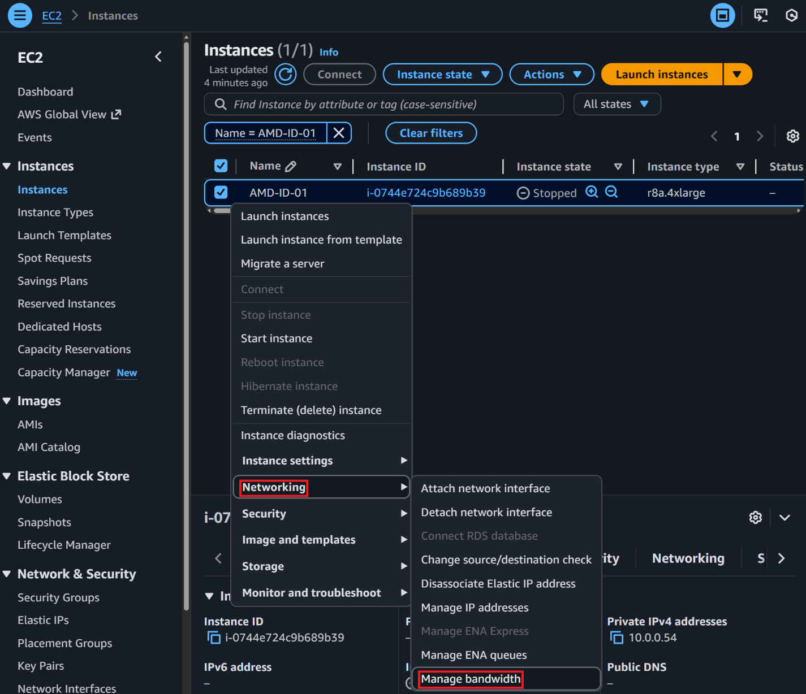
- In the Manage bandwidth page, set the following and select Change:
  - Instance bandwidth configuration: Higher networking bandwidth (vpc-1)

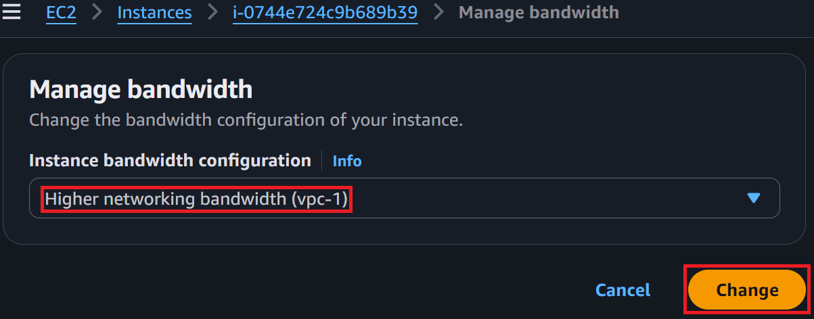

Activity 4-3 Start your instance
- Right-click on the EC2 instance named AMD-ID-01 and select Start instance

The instance will begin its startup sequence and should complete it in 2 minutes or fewer.

Activity 4-4 IO Performance tuning of your AMD instances, the AWS PowerShell way
The PowerShell commands to set the bandwidth weighting on AMD-ID-01 to vpc-1, prioritizing networking bandwidth at the expense of EBS bandwidth.

#### Variables ####
$Region = 'us-west-2'
$DesiredBandwidthWeighting = 'vpc-1'

#### Main ####

Write-Output "Getting EC2 instance information for $InstanceId."
Try {
$InstanceDetails = Get-EC2Instance -Filter @{ Name = 'tag:Name'; Values = 'AMD-ID-01' } -Region $Region -ErrorAction Stop
} Catch [System.Exception] {
Return "Unable to get EC2 instance information. $_"
}

$State = $InstanceDetails | Select-Object -ExpandProperty 'Instances' | Select-Object -ExpandProperty 'State' | Select-Object -ExpandProperty 'Name' | Select-Object -ExpandProperty 'Value'
$InstanceType = $InstanceDetails | Select-Object -ExpandProperty 'Instances' | Select-Object -ExpandProperty 'InstanceType' | Select-Object -ExpandProperty 'Value'
$BandwidthWeighting = $InstanceDetails | Select-Object -ExpandProperty 'Instances' | Select-Object -ExpandProperty 'NetworkPerformanceOptions' | Select-Object -ExpandProperty 'BandwidthWeighting' | Select-Object -ExpandProperty 'Value'

If ($BandwidthWeighting -ne $DesiredBandwidthWeighting) {
If ($State -ne 'stopped') {
Write-Output "EC2 instance $InstanceId is currently running, stopping the EC2 instance to change it's bandwidth weighting configuration to $BandwidthWeighting."
Try {
$Null = Stop-EC2Instance -InstanceId $InstanceId -Force -Region $Region -ErrorAction Stop
} Catch [System.Exception] {
Return "Failed to execute stop command on EC2 instance $InstanceId. $_"
}
Start-Sleep -Seconds 5
$StopInstanceCounter = 0
Do {
$State = Get-EC2Instance -InstanceId $InstanceId -Region $Region -ErrorAction SilentlyContinue | Select-Object -ExpandProperty 'Instances' | Select-Object -ExpandProperty 'State' | Select-Object -ExpandProperty 'Name' | Select-Object -ExpandProperty 'Value'
If ($State -ne 'Stopped') {
$StopInstanceCounter ++
Write-Output "EC2 instance $InstanceId is still stopping, sleeping 5 seconds and will check again."
Start-Sleep -Seconds 5
}
} Until ($State -eq 'Stopped' -or $StopInstanceCounter -ge 120)
}

If ($StopInstanceCounter -ge 60) {
Return "Instance $InstanceId failed to stop in a reasonable time."
}

Write-Output "Updating the EC2 instance $InstanceId bandwidth weighting configuration to $BandwidthWeighting."
Try {
Edit-EC2InstanceNetworkPerformanceOption -InstanceId $InstanceId -BandwidthWeighting 'vpc-1' -Region $Region -ErrorAction Stop
} Catch [System.Exception] {
Return "Failed to update EC2 instance $InstanceId bandwidth weighting configuration to $BandwidthWeighting. $_"
}

Write-Output "Starting EC2 instance $InstanceId."
Try {
$Null = Start-EC2Instance -InstanceId $InstanceId -Force -Region $Region -ErrorAction Stop
} Catch [System.Exception] {
Return "Failed to start EC2 instance $InstanceId. $_"
}

Start-Sleep -Seconds 5
$StartInstanceCounter = 0
Do {
$State = Get-EC2Instance -InstanceId $InstanceId -Region $Region -ErrorAction SilentlyContinue | Select-Object -ExpandProperty 'Instances' | Select-Object -ExpandProperty 'State' | Select-Object -ExpandProperty 'Name' | Select-Object -ExpandProperty 'Value'
If ($State -ne 'Running') {
$StartInstanceCounter ++
Write-Output "EC2 instance $InstanceId is still starting, sleeping 5 seconds and will check again."
Start-Sleep -Seconds 5
}
} Until ($State -eq 'Running' -or $StartInstanceCounter -ge 120)

If ($StartInstanceCounter -ge 60) {
Return "Instance $InstanceId failed to start in a reasonable time."
}
Write-Output "EC2 instance $InstanceId bandwidth weighting configuration to $BandwidthWeighting and back online."
} Else {
Write-Output "EC2 instance $InstanceId instance bandwidth weighting configuration already set to $BandwidthWeighting."
}

Activity 5 – Converting and optimizing to AMD with Amazon RDS
In this activity, you will convert and optimize an Intel-powered db.r5.4xlarge instance to the AMD-powered r8a.4xlarge with 4 vCPUs disabled. In this activity, you have two paths to completion: the console or AWS PowerShell (API). The recommended approach to converting instances in production is to use scripts of IaC using AWS APIs. This prevents accidental human errors and programmatically sets everything as it should be.

Activity 5-1 Change your instance type
- In the RDS Console, select Databases in the left-hand navigation pane
- Select the RDS database identifier amd-id-01 and select Modify
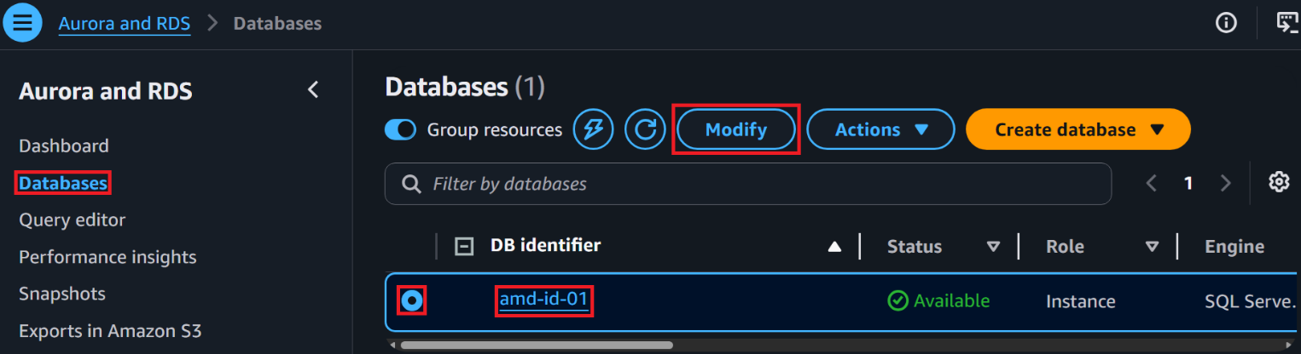
- On the Modify DB instance: amd-id-01 page scroll down to the Instance configuration section and set the following, and select Continue
  - DB instance class: Memory optimized classes (includes r and x classes)
  - Instance type: db.r8a.4xlarge
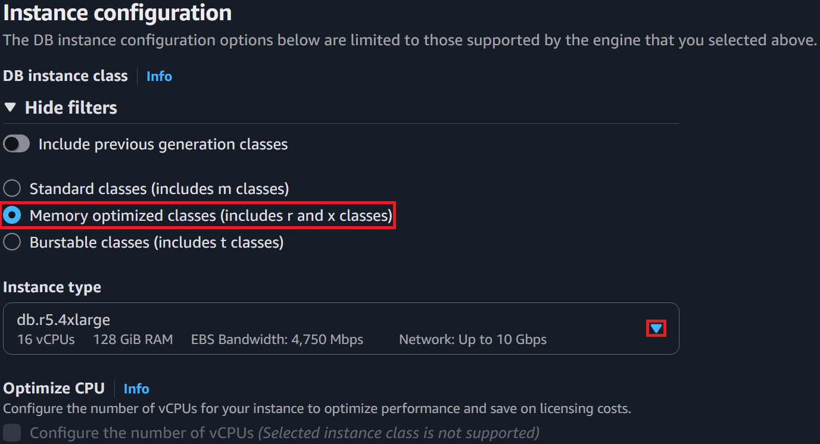
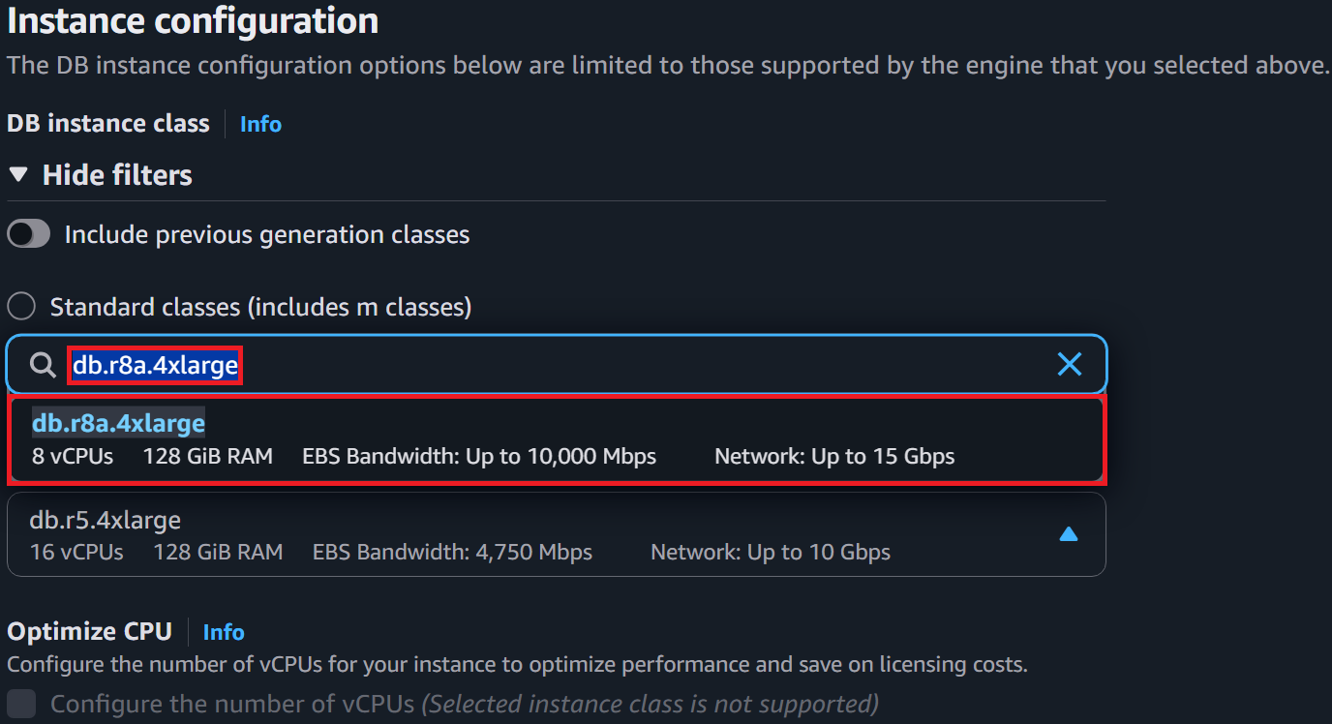
The keen eye may have noticed the Optimize CPU setting on the Modify DB instance: amd-id-01 page. It is possible to optimize and convert at the same time. It is the recommended approach for migrating to AMD-powered instances. For the sake of learning, we are splitting the activities.

- On the Summary of modifications page, select Apply immediately, and select Modify DB instance
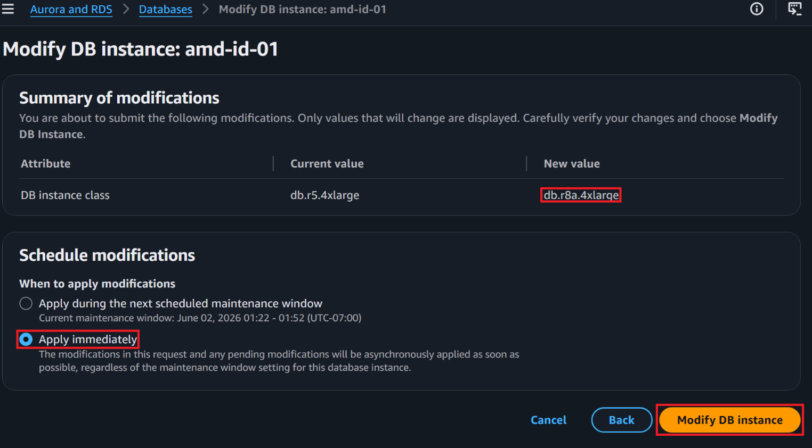
Note: It will take about 10 minutes for the instance modification to complete. You will not be able to make any modifications to the DB while it is updating.
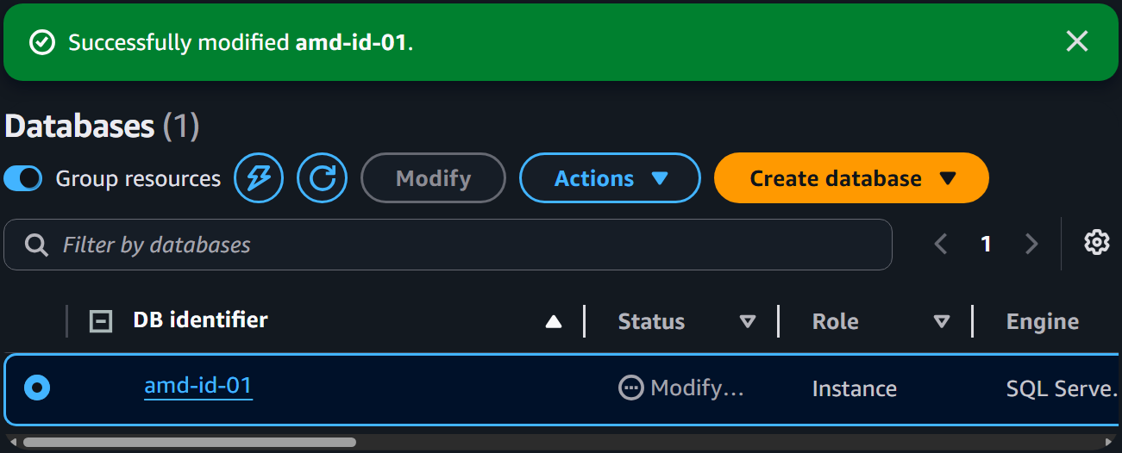
In production, do modifications like these during scheduled maintenance windows. There will be a brief outage while AWS changes the underlying EC2 instances.

Activity 5-1 Converting RDS DB from Intel to AMD, the AWS PowerShell way
Below are the PowerShell commands to convert amd-id-01 from an r5.4xlarge to a r8a.4xlarge.
#### Variables ####
$Region = 'us-west-2'
$DesiredInstanceType = 'r8a.4xlarge'
$DBInstanceIdentifier = 'amd-id-01'

#### Main ####
$CurrentInstanceType = Get-RDSDBInstance -DBInstanceIdentifier $DBInstanceIdentifier -Region $Region -ErrorAction Stop | Select-Object -ExpandProperty 'DBInstanceClass'
If ($CurrentInstanceType -ne $DesiredInstanceType) {
Try {
$Null = Edit-RDSDBInstance -DBInstanceIdentifier $DBInstanceIdentifier -DBInstanceClass $DesiredInstanceType -ApplyImmediately $true -Region $Region -ErrorAction Stop
} Catch [System.Exception] {
Return "Failed to update RDS DB instance $DBInstanceIdentifier to $DesiredInstanceType $_"
}
}

Activity 5-2 – Optimizing your instance
In this activity, you will reduce the vCPU count to 6 vCPUs of your recently converted r8a-4xlarge instance to save money on Windows and SQL licensing without sacrificing performance.
- Select the RDS database identifier amd-id-01 and select Modify
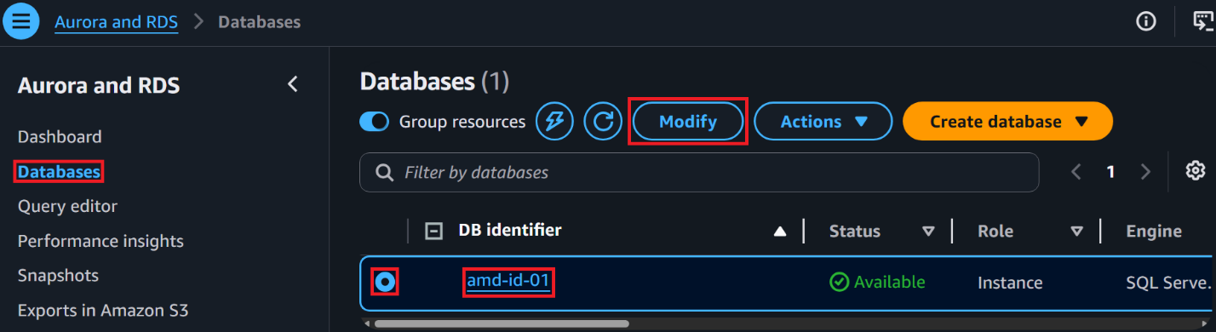
- On the Modify DB instance: amd-id-01 page, scroll down to the Instance configuration section and set the following, and select Continue
  - Optimize CPU: Configure the number of vCPUs, checked
  - vCPUs, thread(s) per CPU core: 1
  - vCPUs, core(s): 6
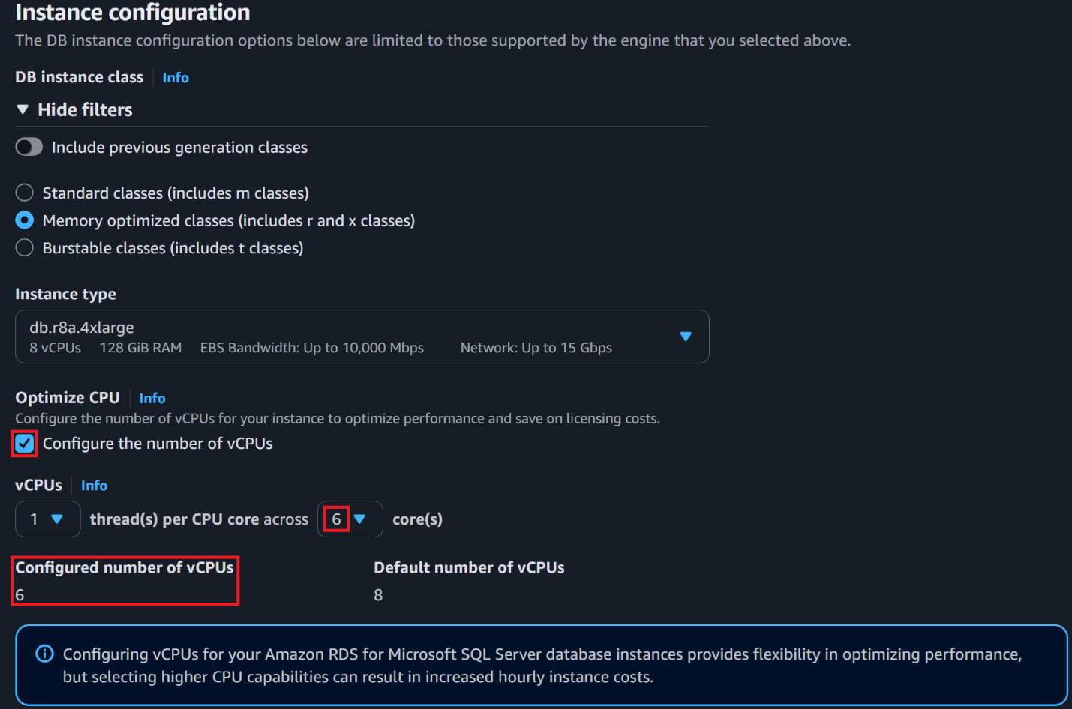
- On the Summary of modifications page, select Apply immediately, and select Modify DB instance
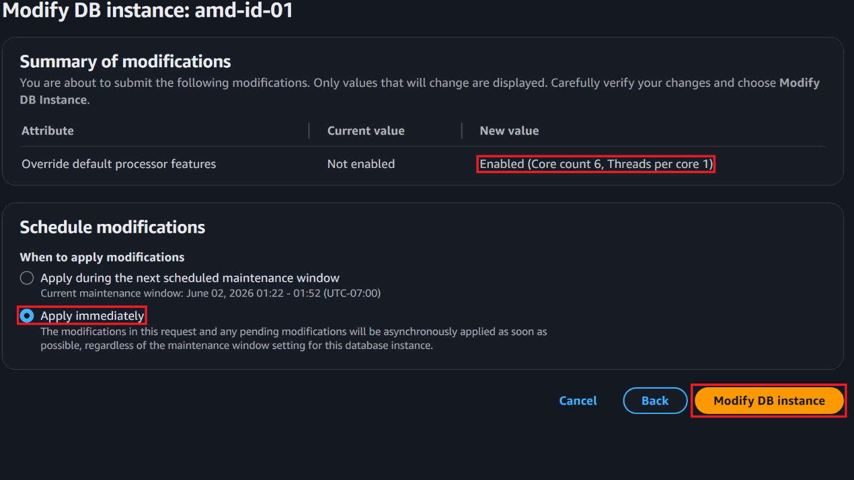
Note: It will take about 10 minutes for the instance modification to complete. You will not be able to make any modifications to the DB while it is updating.


In production, do modifications like these during scheduled maintenance windows. There will be a brief outage while AWS updates the underlying EC2 instances.

Activity 5-2 Optimizing vCPU count to save money on licensing, the AWS PowerShell way
Below are the PowerShell commands to set the vCPU count on amd-id-01 to 6 vCPUs from 8.
#### Variables ####
$Region = 'us-west-2'
$CoreCount = '6'
$ThreadsPerCore = '1'
$DBInstanceIdentifier = 'amd-id-01'

#### Main ####
$CoreFeature = New-Object 'Amazon.RDS.Model.ProcessorFeature'
$CoreFeature.Name = 'coreCount'
$CoreFeature.Value = $CoreCount
$ThreadFeature = New-Object 'Amazon.RDS.Model.ProcessorFeature'
$ThreadFeature.Name = 'threadsPerCore'
$ThreadFeature.Value = $ThreadsPerCore
Try {
Edit-RDSDBInstance -DBInstanceIdentifier $DBInstanceIdentifier -ProcessorFeature $CoreFeature, $ThreadFeature -ApplyImmediately $true -Region $Region -ErrorAction Stop
} Catch [System.Exception] {
Return "Failed to update RDS DB instance $DBInstanceIdentifier vCPU count to $CoreCount threads per core $ThreadsPerCore $_"
}

Activity 6 How to access your CUR
In this activity, you will get hands-on with AWS’s updated billing export mechanism. Specifically, you will export a legacy CUR report to an S3 bucket and then review the contents of the CUR report.

- Go to the Billing and Cost Management Create export console and set:
  - Export type: Legacy CUR report
  - Export name: My-CUR-<your first name>
  - Additional export content, Include resource IDs: Checked
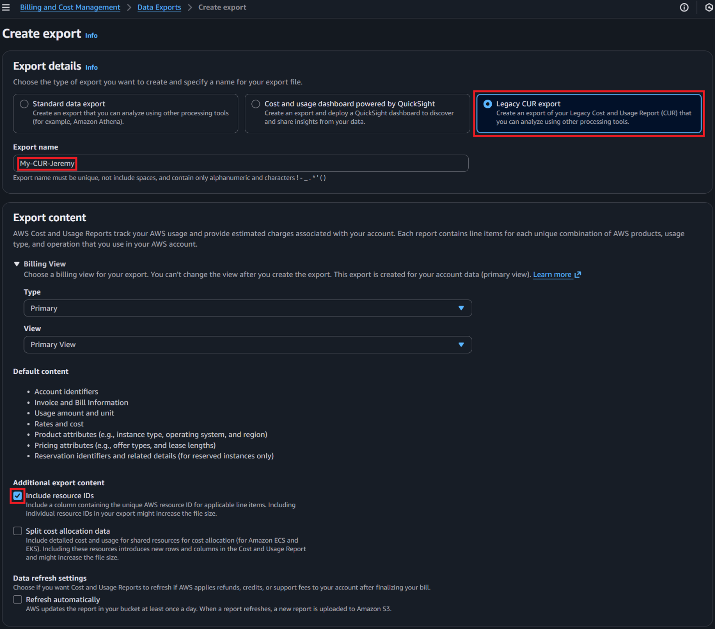
  - S3 bucket, select Configure
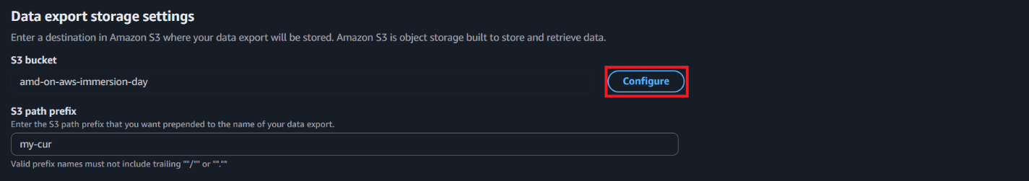

  - Set the following and select Select bucket
    - Select existing bucket: Selected
    - S3 bucket name: amd-on-aws-hands-on-lab-<randomGUID>
    - S3 path prefix: my-cur
    - I agree to overwrite my S3 bucket policy: Checked
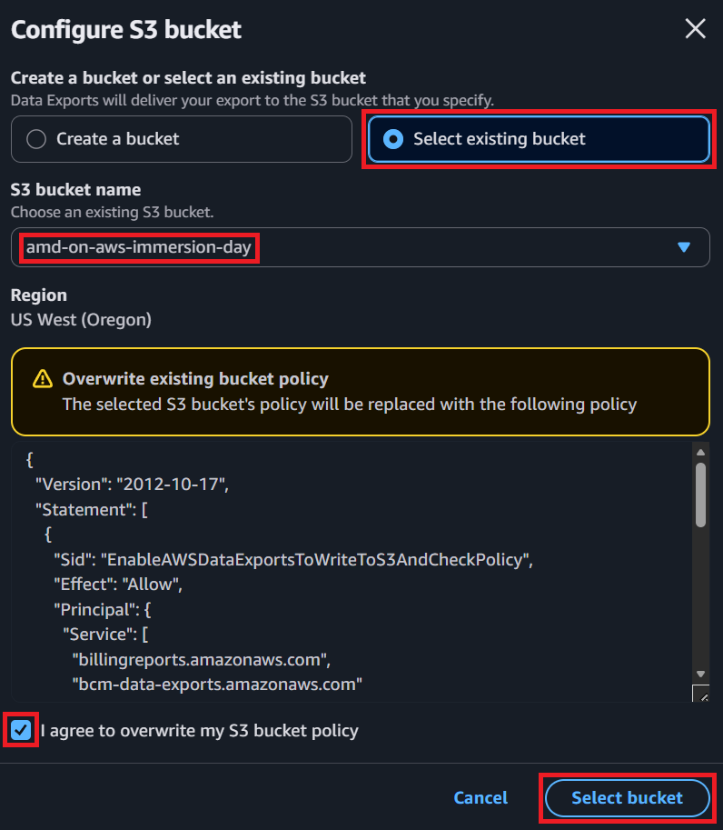

- Select Create report
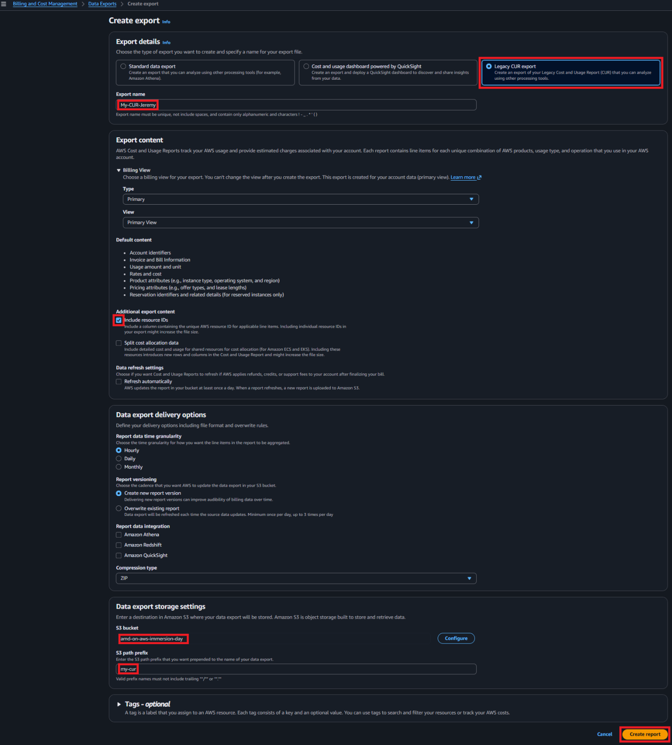

Note: It may take over 3 hours for the report to export to the S3 bucket. You may not have time to review the files.

- Go to the Amazon S3 buckets console and select the bucket named amd-on-aws-immersion-day-<randomGUID>
- In the contents of amd-on-aws-immersion-day-<randomGUID> browse to my-cur / My-CUR-<yourname> / <billing period> / <timestamp> / My-CUR-<yourname>-00001.csv.zip
- Select My-CUR-<yourname>-00001.csv.zip, select Actions, Download as
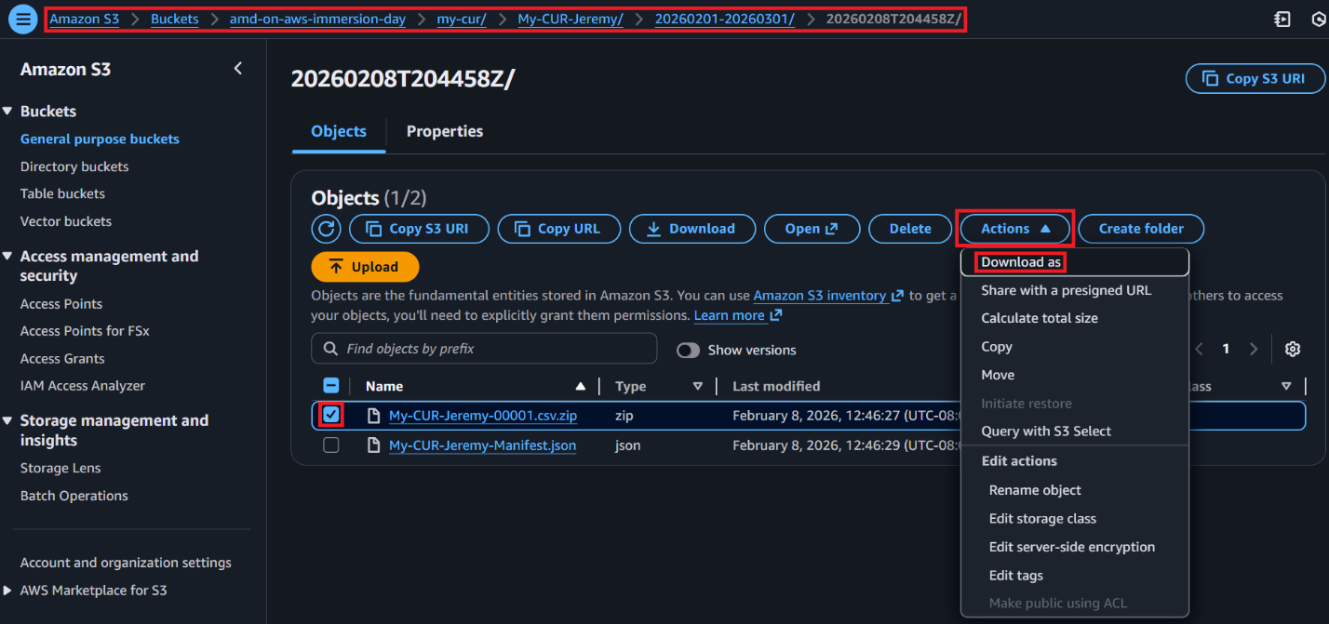
- Select My-CUR-<yourname>-00001.csv.zip to download your CUR and select Close.
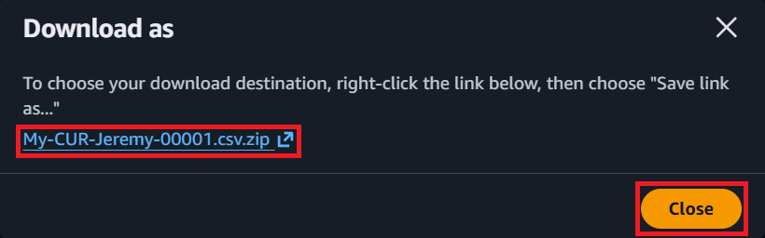
- Browse to your downloads location and double-click the file named My-CUR-<yourname>-00001.csv.zip. Inside the zip file, you will find your CUR csv.
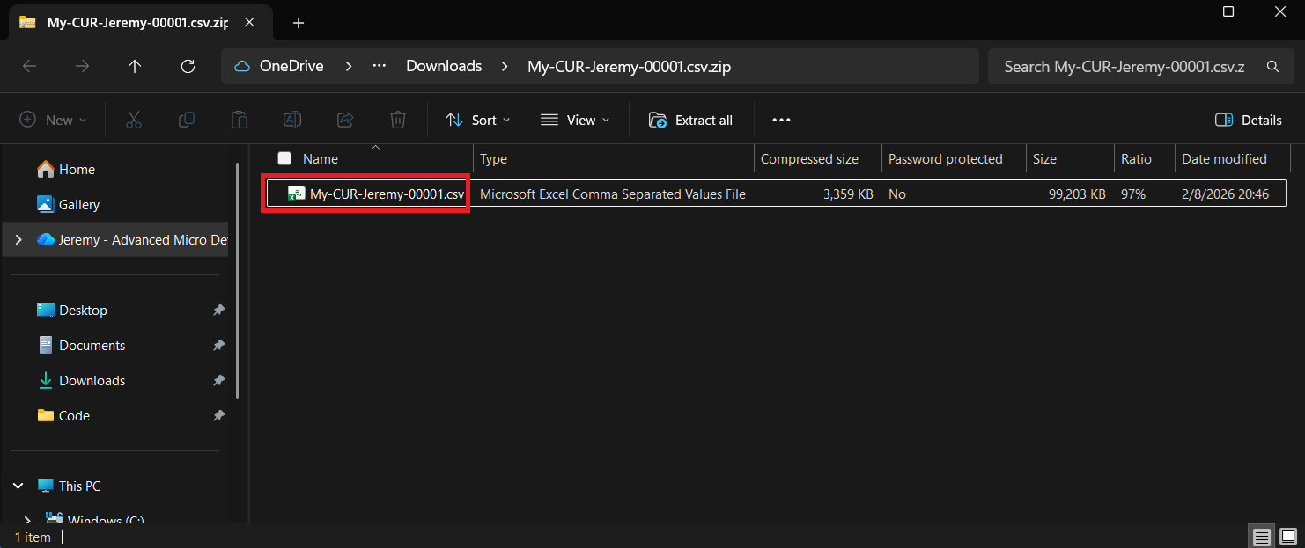

Activity 7 How to upgrade your container workloads to AMD



Additional resources
- AWS Blogs
  - Performance benefits of new Amazon EC2 R8a memory-optimized instances
  - Tuning guide for AMD Amazon EC2 instances
  - Reduce your Microsoft licensing costs by upgrading to 4th generation AMD processors
  - Optimize your x86-based Amazon EC2 Workloads
- AWS Immersion Days
  - General Immersion Day - Basic
  - AWS Networking Immersion Day Workshop
  - AWS Storage Workshop
  - AWS Purpose Built Databases Workshop
- AMD Blogs
  - Guide to Migrating EC2 Workloads
  - Testing Your Cloud's Power Efficiency
  - Advancing the Cloud Together: How AMD and AWS Are Powering the Next Era of Enterprise Efficiency and Innovation
  - AMD EPYC CPUs: The Engines of the Cloud Unleashing Compute at Scale
  - Achieve Continuous, Data-Driven Instance Sizing for Your AMD Powered Amazon EC2 Instances
- AMD Papers
  - Tuning Guide for Amazon EC2 Instances Powered by 1st-4th Gen AMD EPYC Processors

